Project 5: Crop and Weed Detection using YOLOv8

Name: Om Maurya
Internship: Machine Learning Internship

1. Problem Statement: Weeds are unwanted plants in agriculture that consume nutrients, water, and land meant for crops. This leads to reduced crop production. Farmers often use pesticides across the entire field, which wastes chemicals and can contaminate the actual crops.
2. Project Aim: The goal is to develop an automated computer vision system that can distinguish between 'Sesame Crops' and 'Weeds'. This will allow for precision spraying—applying pesticides only on weeds and not on crops, reducing chemical waste and ensuring food safety.
3. Dataset Details:
- Total Images: 1300 images (resized to 512x512 pixels).
- Classes: Two classes - Crop and Weed.
- Format: Images were labeled in YOLO format.
- Preprocessing: Data was split into Training (80%) and Validation (20%) sets using Python scripts.
4. Methodology (Implementation): I used the YOLOv8 (You Only Look Once) object detection model because of its high speed and accuracy in real-time detection.
- Platform: Google Colab (with T4 GPU).
- Framework: Ultralytics YOLO.
- Training: The model was trained for 25 epochs.

5. Results: The model successfully detects weeds and crops with high accuracy. Below is the sample prediction:

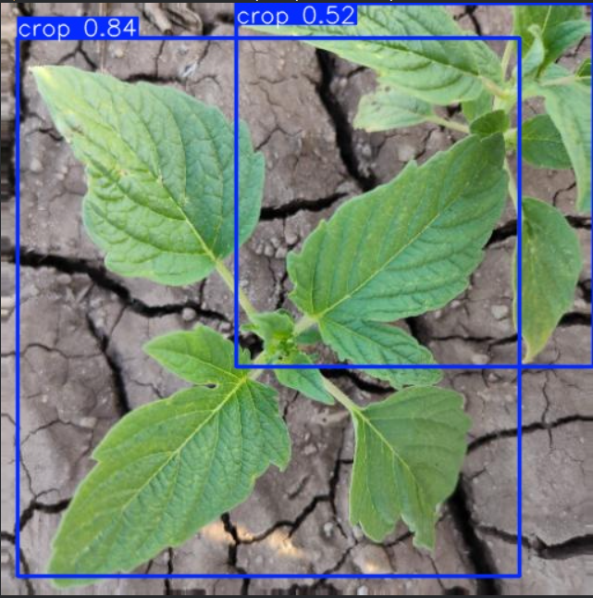

6. Conclusion: This project demonstrates that AI can be effectively used in Smart Agriculture to automate weed detection, helping farmers save costs and improve crop yield.

